**Help Documentation**

## Description

The game of this project is called ‘Fugitive Runner’; where a recently escaped prisoner is on the run inside a large city. The player controls the Fugitive as he attempts to dodge obstacles in his path. The goal of the game is to get as far as possible while the Fugitive slowly runs faster every interval. The player is able to control the Fugitive’s jumps by pressing the jump button. The game is over if the Fugitive touches an object.

## Class Diagram

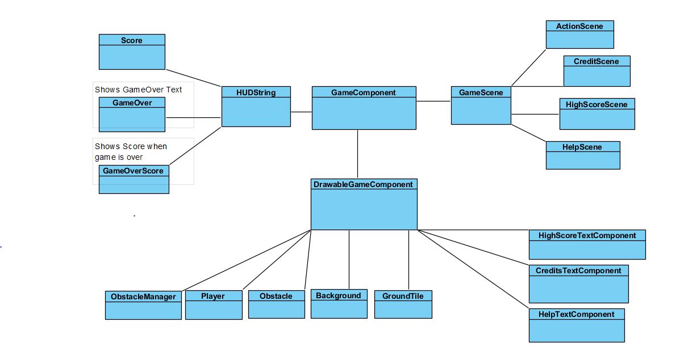

## Assets Used

* City Background: fridaruiz - <https://opengameart.org/content/pixel-night-city>
* Soundtrack: spring - <https://opengameart.org/content/the-simplest-song-ever>
* Character: Blue Yeti Studios - <https://opengameart.org/content/runner-character>
* Tileset: software_atelier - <https://opengameart.org/content/city-pixel-tileset>
* Title Font: Editundo by Ænigma - <https://fontmeme.com/fonts/edit-undo-font/>
* Jumping Sound: dklon - <https://opengameart.org/content/platformer-jumping-sounds>